September is here! Yes, the summer season is winding down, but not our northern Michigan bridge activity. In fact, on Tuesday August 27, you set a record for the largest number of tables to play in a single session game at our club. Thirty (30) tables!!! We crammed an extra table in the overflow room, and added a table and two seats for the sitout table in the entry way. (Check out the photos!) What a wonderful day! Good thing we added to our parking lot!

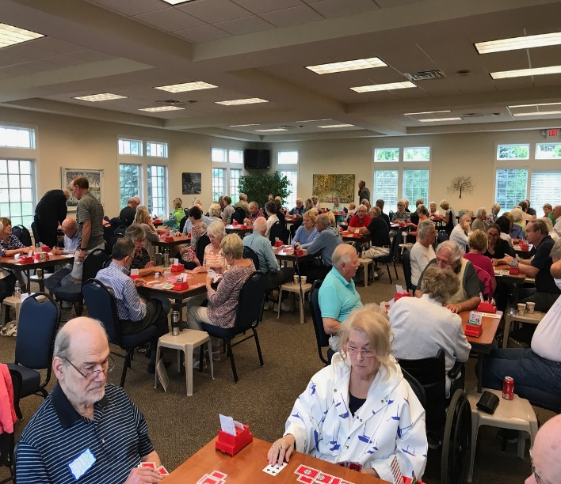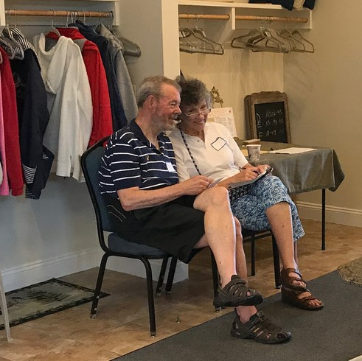

At the end of the month is our bi-annual Petoskey Bridge Club sectional tournament. You’ll want to take advantage of this local opportunity for lots of silver points and to enjoy our new location for the event, the Odawa Casino. And this year there will be 199er sections for every event! Nancy Colbert is the tournament chair. Bob Smith is handling partnerships. Click HERE to see all the details.

Traverse City will hold its sectional September 6-8.
Click HERE for a complete listing of the District 12 tournaments for 2019.

Weekday game schedule – Our weekday game schedule will continue throughout the month with game start time remaining at 10 a.m. Beginning on October 1, game start time will change to 12:30 p.m.

Tenth Anniversary Game – The bridge house opened its doors for play on September 30, 2009. We’ll celebrate that opening with a tenth anniversary game on Tuesday Oct 1, start time 12:30 p.m., with wine & cheese to follow. Mark your calendar!!!

Comments/Concerns – Just a reminder that if you have any comments or concerns resulting from playing at the club, it’s best to let us know directly. Anything from a scoring error to an annoying player to a director call you consider questionable, we’re committed to addressing your concerns. Raising them with the director following the game or sending an email to the club at petoskeybridgeclub@gmail.com are the best ways to let us know. And please let us know the best way to provide you feedback once we have looked into your concern.

Rank Progression – Congratulations to our players who have continued to amass masterpoints and move up the ranks!

  - New Club Masters - Dave Johnson, Gail Torreano, Meredith Quarrier
  - New Sectional Masters - Bridget Hausbeck, Christina Homan
  - New Regional Masters - Mary Kaye Goldblatt, Stuart Goldblatt, Lucia Oelz, Bill Zousmer

Cell Phones Ringing – No more are they ringing! Thank you!!!

Fragrence Free - Remember everyone, the club is fragrance free. Everyone will appreciate your leaving those wonderful fragrances for another time.

Fall Germs – The Fall season brings its own variety of germs for us to deal with at home and especially in social environments like the bridge club. When at the club, please take extra precautions to prevent spreading germs. Clean hands and containing coughs lead the list in doing so.

In Memoriam – We’re saddened to have lost two of our long time players, Adele Sjoberg and Marion Stetson. Our thoughts and prayers go out to their families and friends. They will be missed at the club.

