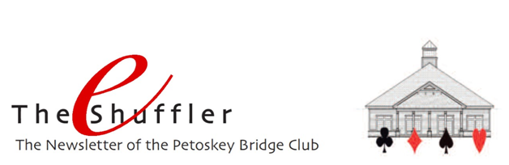

Tenth Anniversary – The bridge house opened its doors for play on September 30, 2009. On October 1, 2019 we celebrated the 10th anniversary! And what a celebration. Twenty-six tables, 104 players, took part. Bridge, fellowship, mental exercise and a wonderful offering of goodies to eat and drink. What could be better!

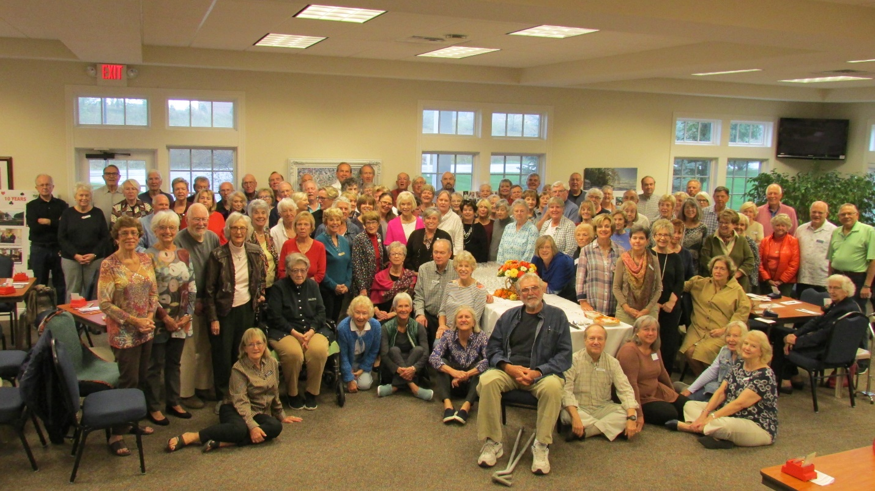

Special thanks to Linda Roberts who not only created posters advertising the event but also three fabulous “memory boards” to document those 10 years and those who have enjoyed playing there. They are special and will continue to be on display for all to see.

Special thanks also to the Hospitality committee - Jeannette Aspenleiter, Janice Smolinski, Catherine Francis, and Gloria Ferris – for their time, energy and talent in presenting and providing the beautiful table of goodies.

And thanks to Jonathan Friendly for his efforts to document our many events, this one included, with his camera. A picture’s worth a thousand words, and his talents keep reminding us of that.

Petoskey Sectional – Awesome! How else can you describe the terrific tournament that we hosted. We had great participation

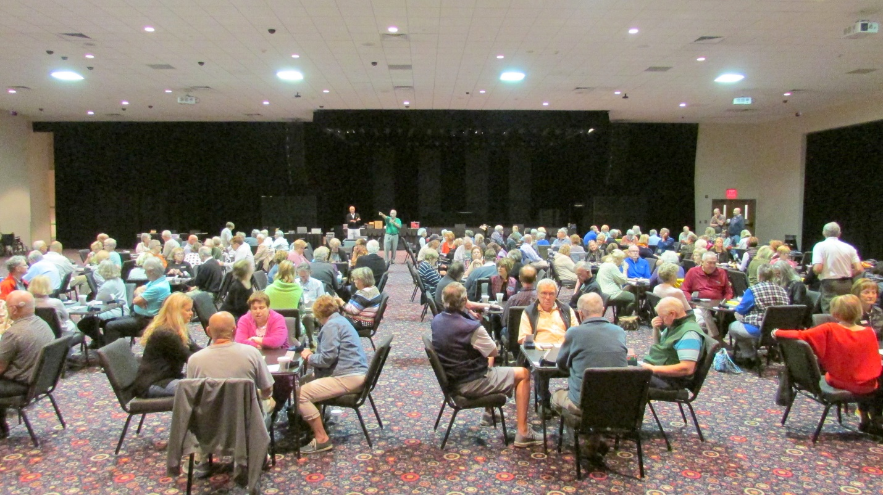

from all over the state, including Unit 195 officers and board members. Our Unit president described the event as “fabulous!” The 197.5 tables of play set a new record of participation for our bi-annual sectional tournament.

Congratulations and thanks to our tournament chair Nancy Colbert and her helpers. And congratulations to all of you who were able to participate. You certainly represented our club well, both in your play and in your friendly demeanor (for which we received several compliments!).

Tournaments – There are still more tournaments for you to consider attending. Click HERE for a complete listing of the District 12 tournaments for 2019.

ALERT! Weekday game schedule – Just a reminder that our daytime games now start at 12:30 p.m.

Single Players – Partners, partners, partners. Yes, bridge is a game that you play with a partner. It’s best if you have a partner ahead of time to ensure that the two of you have coordinated playing schedules and agreements regarding the play. But if you don’t have a partner for a day you’d like to play, we encourage you to come to the club as a single player. We’ll pair you with another single. If there are an odd number of single players, and if we have a volunteer Rover signed up for the day (which we do about half the time), you may be paired with the Rover. There is a possibility that neither of these is the case and you won’t be able to play that day. If you do play with another single player or the Rover, the two of you may not play the same bidding conventions nor play at similar skill levels. While this can be a bit challenging, it should still be a fun day getting to know each other and exploring the variations in play between the two of you. For sure, it will be a day to be particularly nice to your partner!

Our Website – It’s apparent that many of you utilize our website (Petoskeybridgeclub.com) as it’s been visited nearly 19,000 times the last 12 months. Current information such as this week’s schedule and special events are front and center. Our eShufflers are archived under the News/Photos tab then Newsletters. And a roster of players is available with contact information.

Game results are accessible from the Results tab on the left, in between the two photos of the bridge house. This tab will take you to our results website: https://www.bridgewebs.com/petoskey/ Here you can find not only the game results but a complete review of the game
including:
- how you and everyone else did on each board.
- the contract and lead on each board for all players.
- the hand record for each board which shows the cards in each hand, the number of high card points in each hand, and an analysis indicating contracts that are makeable if well defended.

If you have thoughts about how we might make these websites more useful, please let us know.

Do’s and Don’ts – It never hurts to remind ourselves of some of the things we should do (and not do) at the bridge table:
- Do be a good host and a good guest
- Do greet others with a friendly smile
- Do compliment opponents on good play
- Do come to the game fragrance free
- Do decide your bid before reaching to the bid box
- Don’t be rude or intimidating
- Don’t criticize the play of your partner nor the opponents
- Don’t offer “lessons” during the game
- Don’t argue with the director
- Don’t snap your cards when you play them

